

**ITA05 – COMPUTER VISION**

1. Perform basic Image Handling and processing operations on the image. • Read an image in python and Convert an Image to Grayscale

AIM:

To Perform Basic Operations to Read Image and Convert to Grayscale using Python

PROGRAM:

import cv2

import numpy as np

kernel = np.ones((5,5),np.uint8) print(kernel)

path = "C:/Users/Welcome/OneDrive/Pictures/Saved Pictures/cat.jpeg" img =cv2.imread(path)

imgGray = cv2.cvtColor(img,cv2.COLOR_BGR2GRAY) cv2.imshow("GrayScale",imgGray)

cv2.waitKey(0)

INPUT:



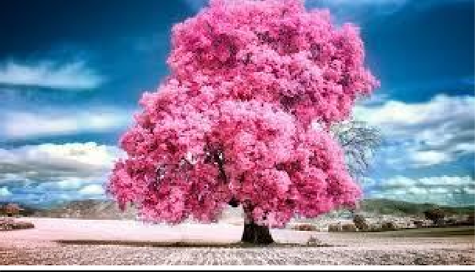

OUTPUT:

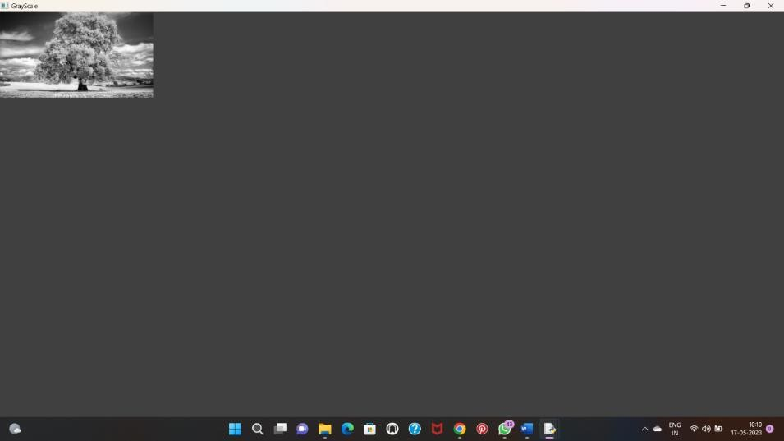

1. Perform basic Image Handling and processing operations on the image.• Read an image in python and Convert an Image to Blur using GaussianBlur.

AIM:

To Perform Basic Operations to Read Image and Convert to Blur using GaussianBlur.

PROGRAM

import cv2

import numpy as np

kernel = np.ones((5,5),np.uint8) print(kernel)

path = "C:/Users/divya/OneDrive/Documents/COMPUTER VISION/Picture2.jpg" img =cv2.imread(path)

imgGray = cv2.cvtColor(img,cv2.COLOR_BGR2GRAY) imgBlur = cv2.GaussianBlur(imgGray,(7,7),0)

cv2.imshow("Img Blur",imgBlur) cv2.waitKey(0)



INPUT:



OUTPUT:

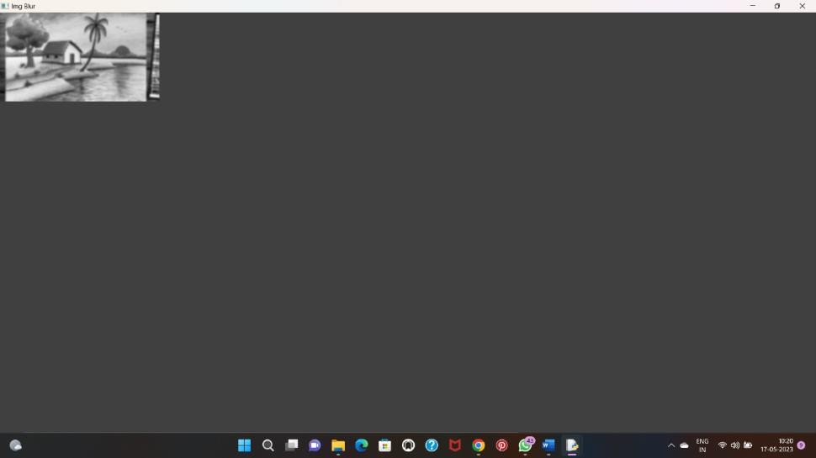

1. Perform basic Image Handling and processing operations on the image• Read an image in python and Convert an Image to show outline using Canny function

AIM:

To Perform Basic Operations to Convert image to show outline Canny function in Python

PROGRAM:

import cv2

import numpy as np

kernel = np.ones((5,5),np.uint8) print(kernel)

path = "C:/Users/divya/OneDrive/Documents/COMPUTER VISION/CANNY.jpg" img =cv2.imread(path)

imgGray = cv2.cvtColor(img,cv2.COLOR_BGR2GRAY) imgBlur = cv2.GaussianBlur(imgGray,(7,7),0)

imgCanny = cv2.Canny(imgBlur,100,200) cv2.imshow("Img Canny",imgCanny)



cv2.waitKey(0)

INPUT:

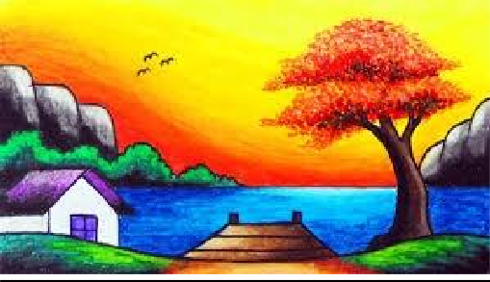

OUTPUT:

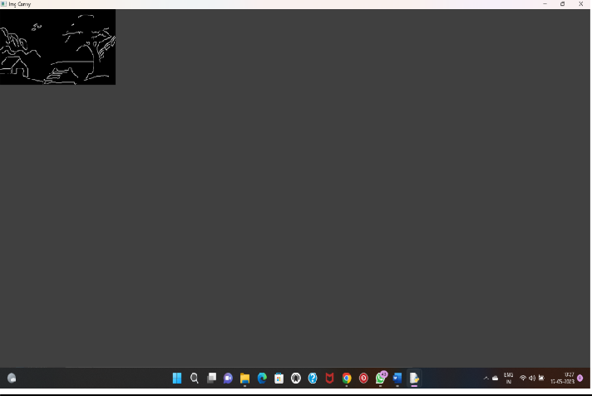

1. Perform basic Image Handling and processing operations on the image• Read an image in python and Dilate an Image using Dilate function



AIM:

To Perform Basic Operations to Read Image and Dilate an Image using Python

import cv2

import numpy as np

image_path ="E:/Computer Vision/computer vision input and output/4.Image using Dilate function input.png"

image = cv2.imread(image_path, cv2.IMREAD_GRAYSCALE)

cv2.imshow("original image",image)

cv2.waitKey(0)

kernel = np.ones((5, 5), np.uint8)

dilated_image = cv2.dilate(image, kernel, iterations=1)

cv2.imshow('Dilated Image', dilated_image)

cv2.waitKey(0)

cv2.destroyAllWindows()



PROGRAM:



import cv2



import numpy as np



kernel = np.ones((5,5),np.uint8)



print(kernel)



path = "C:/Users/divya/OneDrive/Documents/COMPUTER VISION/dialation.jpg"



img =cv2.imread(path)



imgGray = cv2.cvtColor(img,cv2.COLOR_BGR2GRAY)



imgBlur = cv2.GaussianBlur(imgGray,(7,7),0)



imgCanny = cv2.Canny(imgBlur,100,200)

INPUT OUTPUT

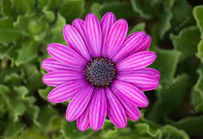 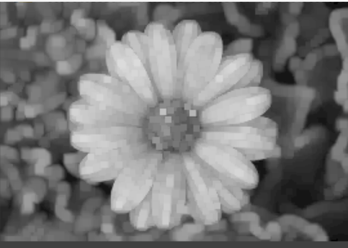

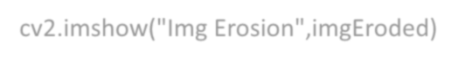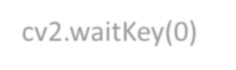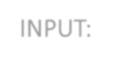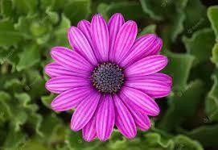

imgDilation = cv2.dilate(imgCanny,kernel , iterations = 10)

imgEroded = cv2.erode(imgDilation,kernel,iterations=2)

cv2.imshow("Img Erosion",imgEroded) cv2.waitKey(0)

INPUT:



OUTPUT:

1. Perform basic Image Handling and processing operations on the image• Read an image in python and Erode an Image using erode function

AIM:

The Aim of the experiment is to Read an image in python and Erode an Image using erode function PROGRAM:

import cv2

import numpy as np

kernel = np.ones((5,5),np.uint8) print(kernel)

path = "C:/Users/divya/OneDrive/Documents/COMPUTER VISION/erosion.jpg" img =cv2.imread(path)

imgGray = cv2.cvtColor(img,cv2.COLOR_BGR2GRAY) imgBlur = cv2.GaussianBlur(imgGray,(7,7),0)

imgCanny = cv2.Canny(imgBlur,100,200)

imgDilation = cv2.dilate(imgCanny,kernel , iterations = 10) imgEroded = cv2.erode(imgDilation,kernel,iterations=2)



cv2.imshow("Img Erosion",imgEroded) cv2.waitKey(0)

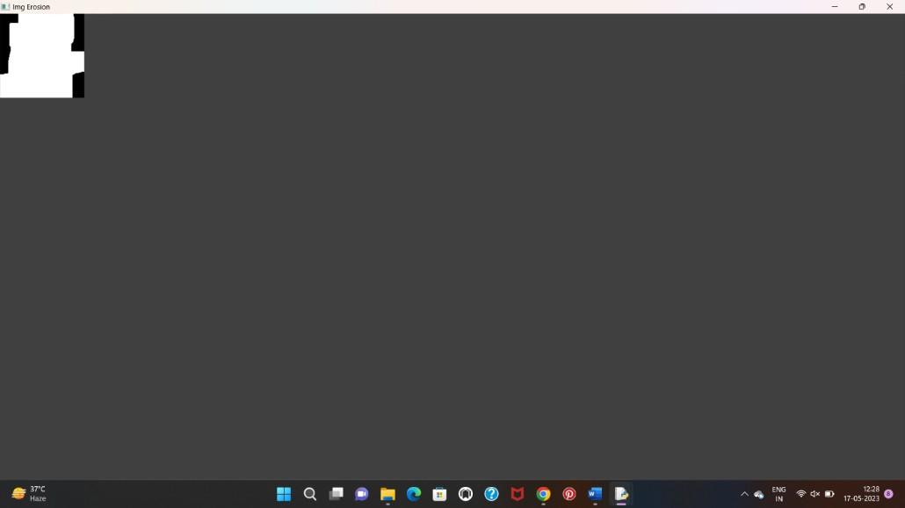INPUT:



OUTPUT:

1. Perform basic video processing operations on the captured video• Read captured video in python and display the video, in slow motion and in fast motion.

AIM:

The Aim of the Experiment is to Read captured video in python and display the video, in slow motion and in fast motion

PROGRAM:

import cv2

import numpy as np

cap = cv2.VideoCapture("C:/Users/divya/OneDrive/Documents/COMPUTER VISION/13 REASONS WHY")

if (cap.isOpened()== False):

print("Error opening video file") while(cap.isOpened()):

ret, frame = cap.read() if ret == True:

cv2.imshow('Frame',frame)

if cv2.waitKey(250) & 0xFF == ord('q'): break

else:

break

cap.release()

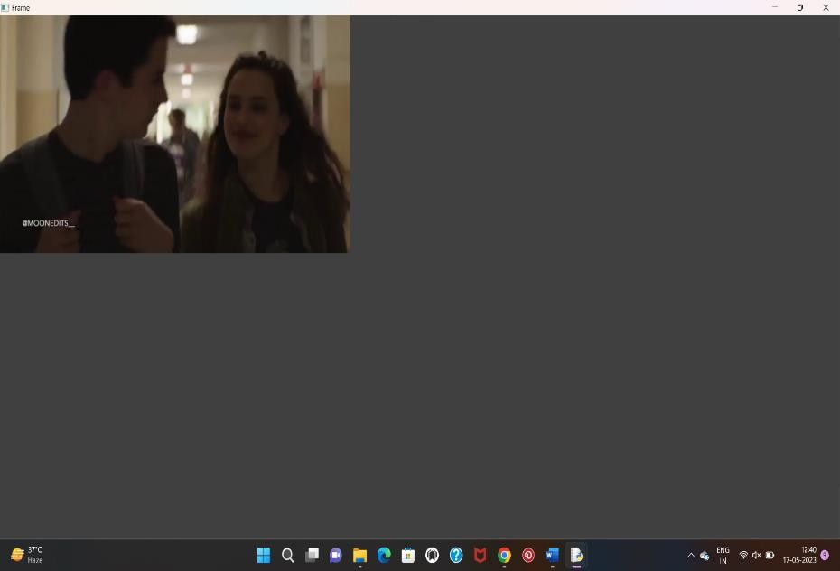cv2.destroyAllWindows() INPUT:

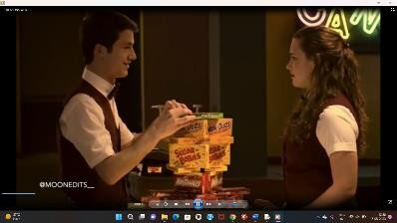

OUTPUT:

1. Capture video from web Camera and Display the video, in slow motion and in fast motion operations on the captured video

AIM:

The Aim is to Capture video from web Camera and Display the video, in slow motion and in fast motion operations on the captured video

PROGRAM:

import cv2

cap = cv2.VideoCapture(0)

height = int(cap.get(cv2.CAP_PROP_FRAME_HEIGHT)) width = int(cap.get(cv2.CAP_PROP_FRAME_WIDTH)) fps = cap.get(cv2.CAP_PROP_FPS)

path = "0"

fourcc = cv2.VideoWriter_fourcc(*'mp4v')

output = cv2.VideoWriter(path, fourcc, 2,(width, height)) while True:

ret, frame= cap.read() cv2.imshow("frame", frame) output.write(frame)

k = cv2.waitKey(24) if k == ord("q"):

break cap.release() output.release()

cv2.destroyAllWindows() OUTPUT:

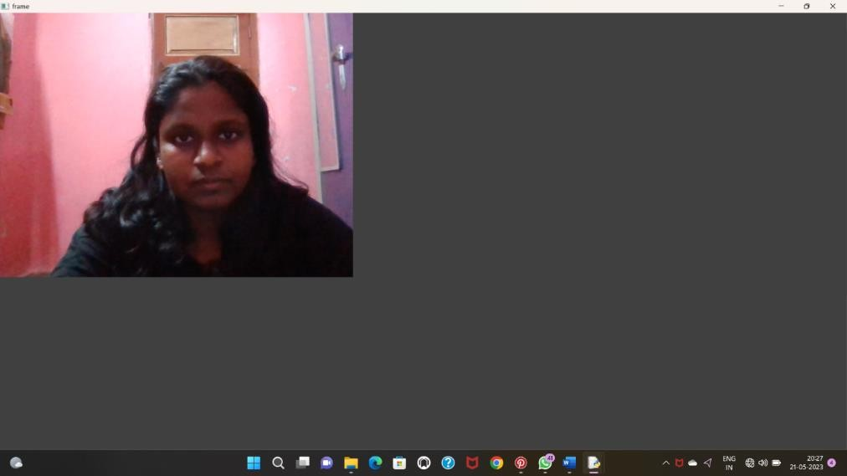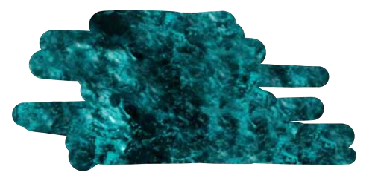

1. **Scaling an image to its Bigger and Smaller sizes.**

AIM:

The Aim is resize the image from bigger to smaller size PROGRAM:

import cv2

import numpy as np

kernel = np.ones((5,5),np.uint8)

img = cv2.imread("C:/Users/Welcome/OneDrive/Pictures/Saved Pictures/cat.jpeg",cv2.IMREAD_COLOR)

img = cv2.resize(img,(600,600)) cv2.imshow("Output image",img) cv2.waitKey(0)

INPUT:

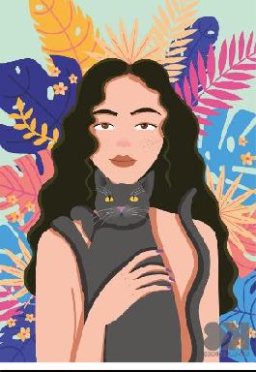

OUTPUT:

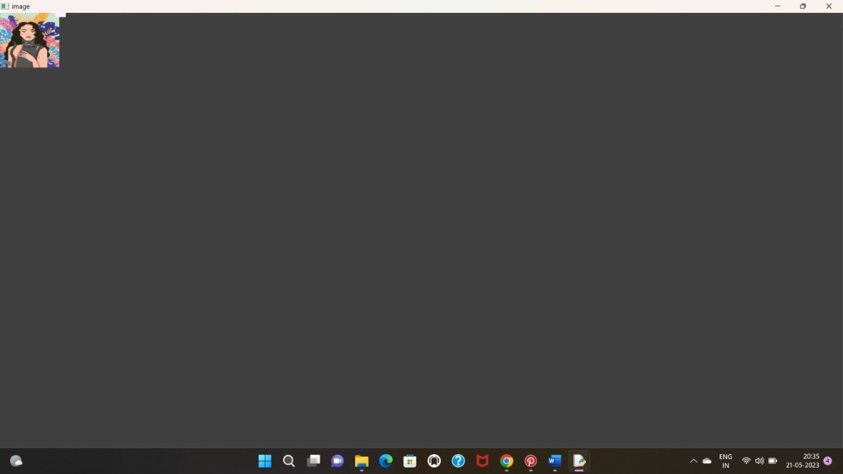

1. Perform Rotation of an image to clockwise and counter clockwise direction.

ROTATION 90 ALONG DEGREE:

AIM

The Aim of the Experiment is to perform Rotation of an image along 90 degree PROGRAM

import cv2

path r"C:/Users/Welcome/OneDrive/Pictures/SavedPictures/cat.jpeg" src = cv2.imread(path)

window_name = 'Image'

image = cv2.rotate(src, cv2.ROTATE_180) cv2.imshow(window_name, image) cv2.waitKey(0)

INPUT

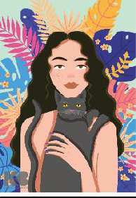

OUTPUT

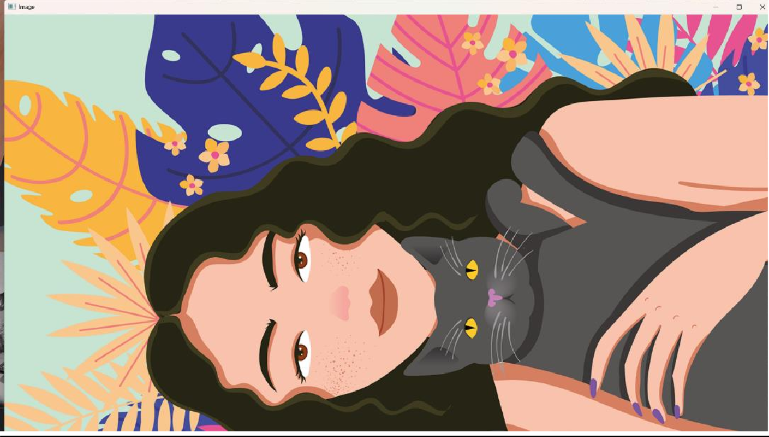

ROTATION ALONG 180 DEGREE

AIM

The Aim of the Experiment is to perform Rotation of an image along 180 degree PROGRAM

import cv2

path = r"C:/Users/divya/OneDrive/Documents/COMPUTER VISION/Girl with a Cat.png" src = cv2.imread(path)

window_name = 'Image'

image = cv2.rotate(src, cv2.ROTATE_90_COUNTERCLOCKWISE) # Displaying the image

cv2.imshow(window_name, image) cv2.waitKey(0)

OUTPUT

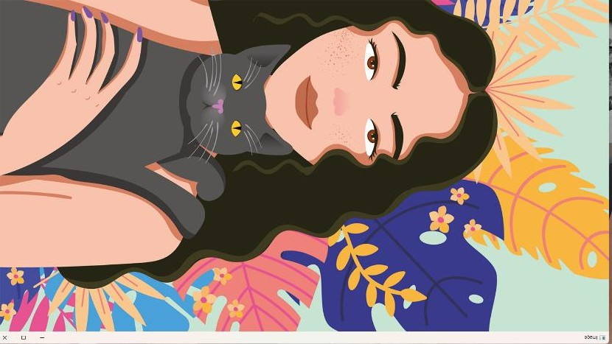

ROTATION ALONG 270 DEGREE

AIM

The Aim of the Experiment is to perform Rotation of an image along 270 degree PROGRAM

import cv2

path = r"C:/Users/Welcome/OneDrive/Pictures/Saved Pictures/cat.jpeg" src = cv2.imread(path)

window_name = 'Image'

image = cv2.rotate(src, cv2.ROTATE_90_COUNTERCLOCKWISE) cv2.imshow(window_name, image)

cv2.waitKey(0) OUTPUT



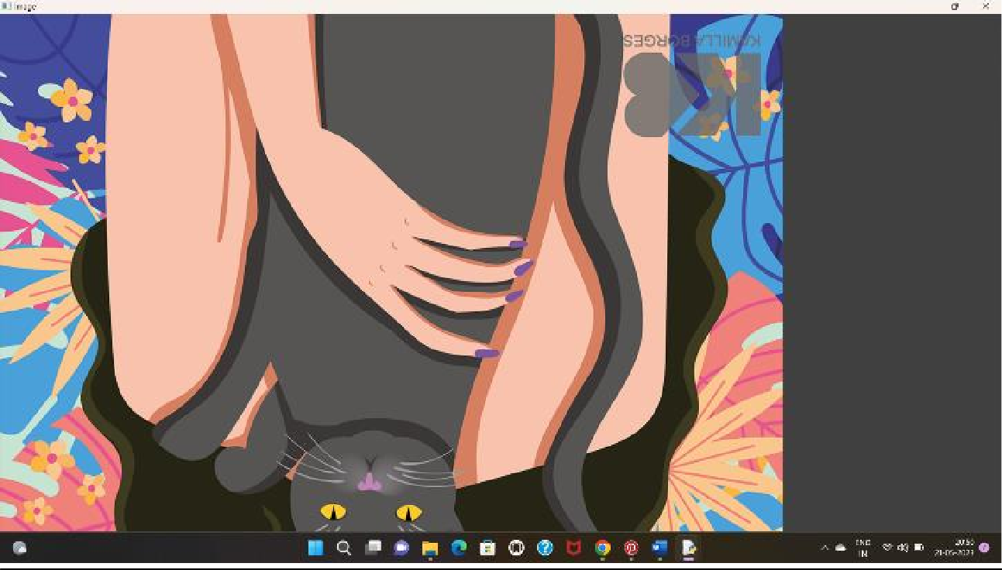

1. Perform moving of an image from one place to another.

**Program**

import cv2

import numpy as np

image = cv2.imread("E:/Computer Vision/computer vision input and output/8.scaling an image input.png")

if image is not None:

tx = 50

ty = 30

translation_matrix = np.float32([[1, 0, tx], [0, 1, ty]])

translated_image = cv2.warpAffine(image, translation_matrix, (image.shape[1], image.shape[0]))

cv2.imshow("Original Image", image)

cv2.imshow("Translated Image", translated_image)

cv2.waitKey(0)

cv2.destroyAllWindows()

else:

print("Error: Could not load the image.")

INPUT OUTPUT

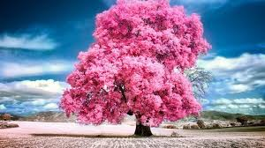 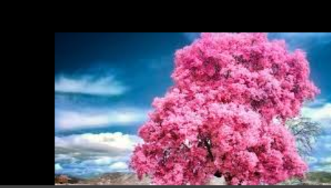

1. Perform Affine Transformation on the image.

PROGRAM:

import cv2

import numpy as np

# read the input image

img = cv2.imread("C:/Users/Welcome/OneDrive/Pictures/Saved Pictures/afiine.jpg") # access the image height and width

rows,cols,ch = img.shape

# define at three point on input image

pts1 = np.float32([[50,50],[200,50],[50,200]])

# define three points corresponding location to output image pts2 = np.float32([[10,100],[200,50],[100,250]])

# get the affine transformation Matrix M = cv2.getAffineTransform(pts1,pts2)

# apply affine transformation on the input image

dst = cv2.warpAffine(img,M,(cols,rows)) cv2.imshow("Affine Transform", dst)

cv2.waitKey(0)

cv2.destroyAllWindows() OUTPUT

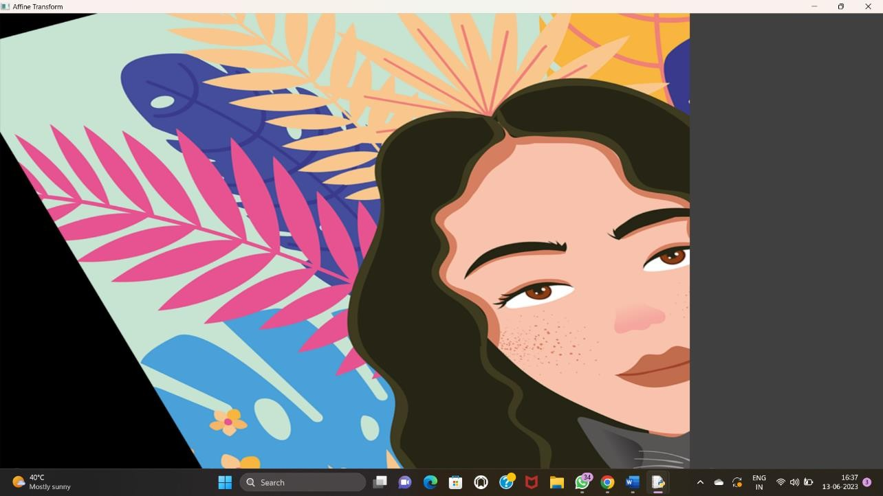

1. Perform Perspective Transformation on the image.

PROGRAM

# import required libraries import cv2

import numpy as np

# read the input image

img = cv2.imread("C:/Users/Welcome/OneDrive/Pictures/Saved Pictures/afiine.jpg") # find the height and width of image

# width = number of columns, height = number of rows in image array rows,cols,ch = img.shape

# define four points on input image

pts1 = np.float32([[56,65],[368,52],[28,387],[389,390]])

# define the corresponding four points on output image pts2 = np.float32([[100,50],[300,0],[0,300],[300,300]])

# get the perspective transform matrix

M = cv2.getPerspectiveTransform(pts1,pts2)

# transform the image using perspective transform matrix dst = cv2.warpPerspective(img,M,(cols, rows))

# display the transformed image cv2.imshow('Transformed Image', dst) cv2.waitKey(0)

cv2.destroyAllWindows() OUTPUT

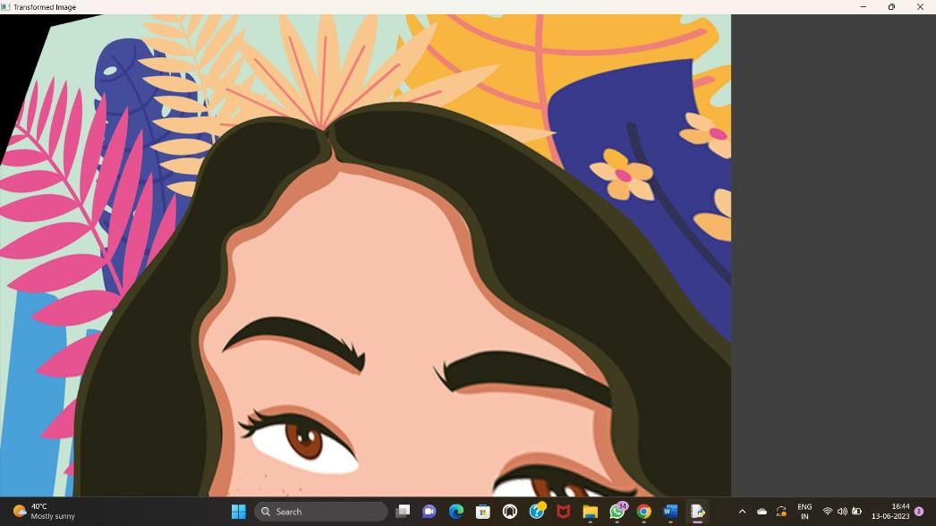

1. Perform Perspective Transformation on the Video.

PROGRAM:

import cv2

import numpy as np

cap = cv2.VideoCapture("C:/Users/Welcome/Downloads/pexels-pixabay-855029-1920x1080- 60fps.mp4")

while True:

ret, frame = cap.read()

pts1 = np.float32([[200,300], [5, 2],

[0, 4], [6, 0]])

pts2 = np.float32([[0, 0], [4, 0],

[0, 1], [4, 6]])

matrix = cv2.getPerspectiveTransform(pts1, pts2) result = cv2.warpPerspective(frame, matrix, (0, 0)) cv2.imshow('frame', frame) # Initial Capture

cv2.imshow('frame1', result) # Transformed Capture

if cv2.waitKey(24) == 27:

break

cap.release()

cv2.destroyAllWindows() OUPUT:

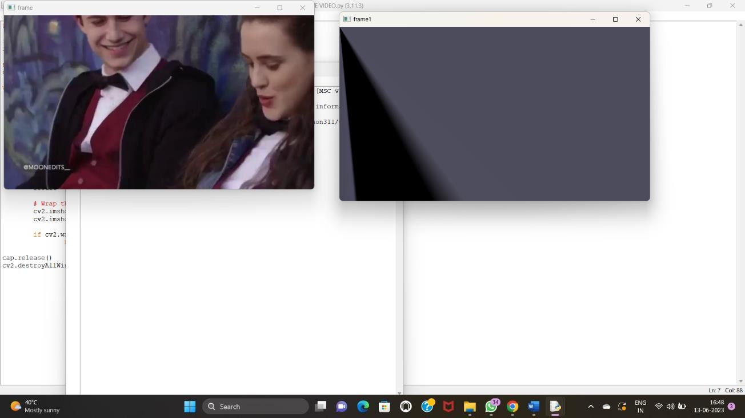

1. Perform transformation using Homography matrix PROGRAM:

import cv2

import numpy as np

# Read source image.

im_src = cv2.imread("C:/Users/Welcome/OneDrive/Pictures/Saved Pictures/afiine.jpg") # Four corners of the book in source image

pts_src = np.array([[141, 131], [480, 159], [493, 630],[64, 601]])

# Read destination image.

im_dst = cv2.imread("C:/Users/Welcome/OneDrive/Pictures/Saved Pictures/afiine.jpg") # Four corners of the book in destination image.

pts_dst = np.array([[318, 256],[534, 372],[316, 670],[73, 473]])

# Calculate Homography

h, status = cv2.findHomography(pts_src, pts_dst)

# Warp source image to destination based on homography

im_out = cv2.warpPerspective(im_src, h, (im_dst.shape[1],im_dst.shape[0])) # Display images

cv2.imshow("Source Image", im_src) cv2.imshow("Destination Image", im_dst) cv2.imshow("Warped Source Image", im_out) cv2.waitKey(0)

# OUTPUT:

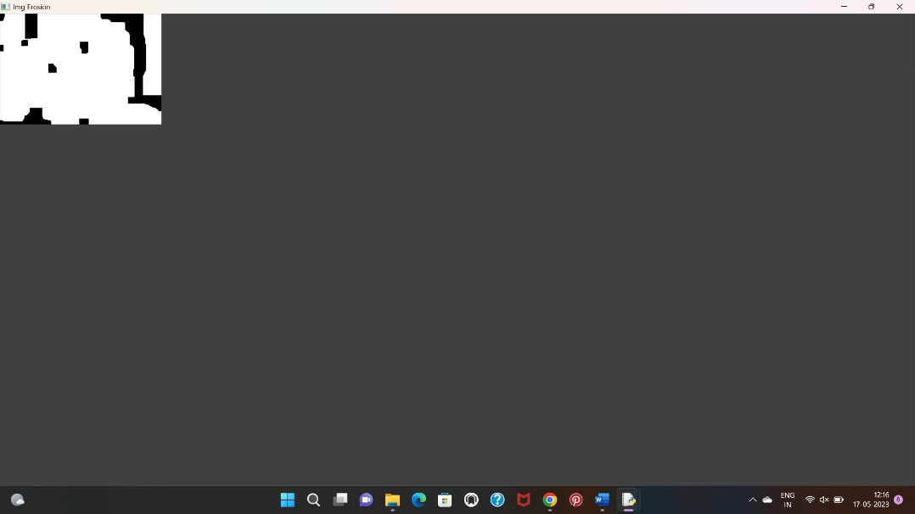

1. Perform transformation using Direct Linear Transformation

# PROGRAM

import cv2

import numpy as np # Load images

img1 = cv2.imread("C:/Users/Welcome/OneDrive/Pictures/Saved Pictures/afiine.jpg") img2 = cv2.imread("C:/Users/Welcome/OneDrive/Pictures/Saved Pictures/cat.jpeg") # Define corresponding points

pts1 = np.array([[50, 50], [200, 50], [50, 200], [200, 200]])

pts2 = np.array([[100, 100], [300, 100], [100, 300], [300, 300]])

# Estimate projective transformation matrix using DLT H, _ = cv2.findHomography(pts1, pts2)

# Apply projective transformation to img1

dst = cv2.warpPerspective(img1, H, (img2.shape[1], img2.shape[0])) # Display images

cv2.imshow('img1', img1) cv2.imshow('img2', img2) cv2.imshow('dst', dst)

cv2.waitKey(0)

cv2.destroyAllWindows()

# OUTPUT

1. Perform Edge detection using canny method

PROGRAM:

import cv2

img = cv2.imread("C:/Users/Welcome/OneDrive/Pictures/Saved Pictures/cat.jpeg") cv2.imshow('Original', img)

cv2.waitKey(0)

img_gray = cv2.cvtColor(img, cv2.COLOR_BGR2GRAY) img_blur = cv2.GaussianBlur(img_gray, (3,3), 0)

edges = cv2.Canny(image=img_blur, threshold1=100, threshold2=200) # Canny Edge Detection cv2.imshow('Canny Edge Detection', edges)

cv2.waitKey(0)

cv2.destroyAllWindows()

OUPUT:

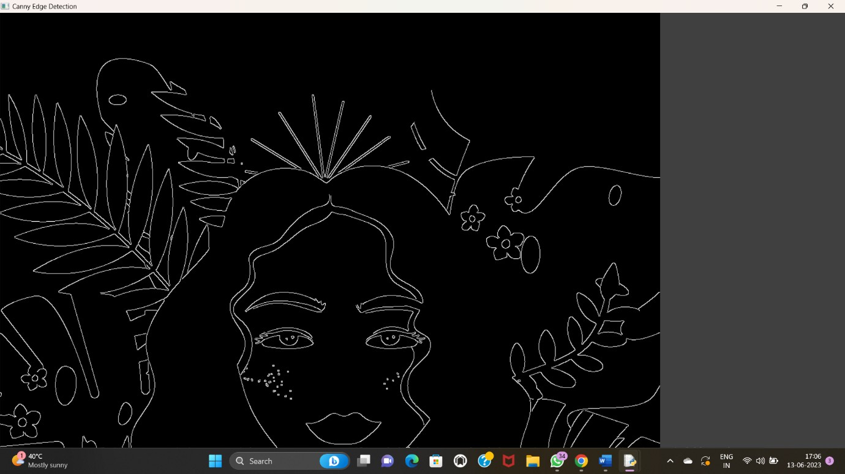

1. Perform Edge detection using Sobel Matrix along X axis

PROGRAM:

import cv2

img = cv2.imread("C:/Users/Welcome/OneDrive/Pictures/Saved Pictures/cat.jpeg") cv2.imshow('Original', img)

cv2.waitKey(0)

img_gray = cv2.cvtColor(img, cv2.COLOR_BGR2GRAY) # Blur the image for better edge detection

img_blur = cv2.GaussianBlur(img_gray, (3,3), 0)

sobelx = cv2.Sobel(src=img_blur, ddepth=cv2.CV_64F, dx=1, dy=0, ksize=5) # Sobel Edge Detection on the X axis

cv2.imshow('Sobel X', sobelx) cv2.waitKey(0)

OUTPUT:

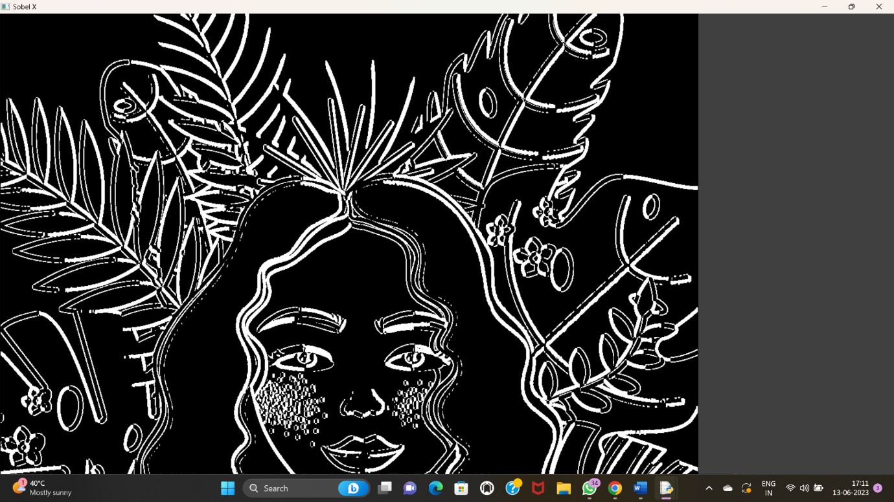

1. Perform Edge detection using Sobel Matrix along Y axis

PROGRAM:

import cv2

# Read the original image

img = cv2.imread("C:/Users/Welcome/OneDrive/Pictures/Saved Pictures/cat.jpeg") # Display original image

cv2.imshow('Original', img) cv2.waitKey(0)

# Convert to graycsale

img_gray = cv2.cvtColor(img, cv2.COLOR_BGR2GRAY) # Blur the image for better edge detection

img_blur = cv2.GaussianBlur(img_gray, (3,3), 0) # Sobel Edge Detection

sobely = cv2.Sobel(src=img_blur, ddepth=cv2.CV_64F, dx=0, dy=1, ksize=5) # Sobel Edge

Detection on the Y axis

# Display Sobel Edge Detection Images cv2.imshow('Sobel Y', sobely)

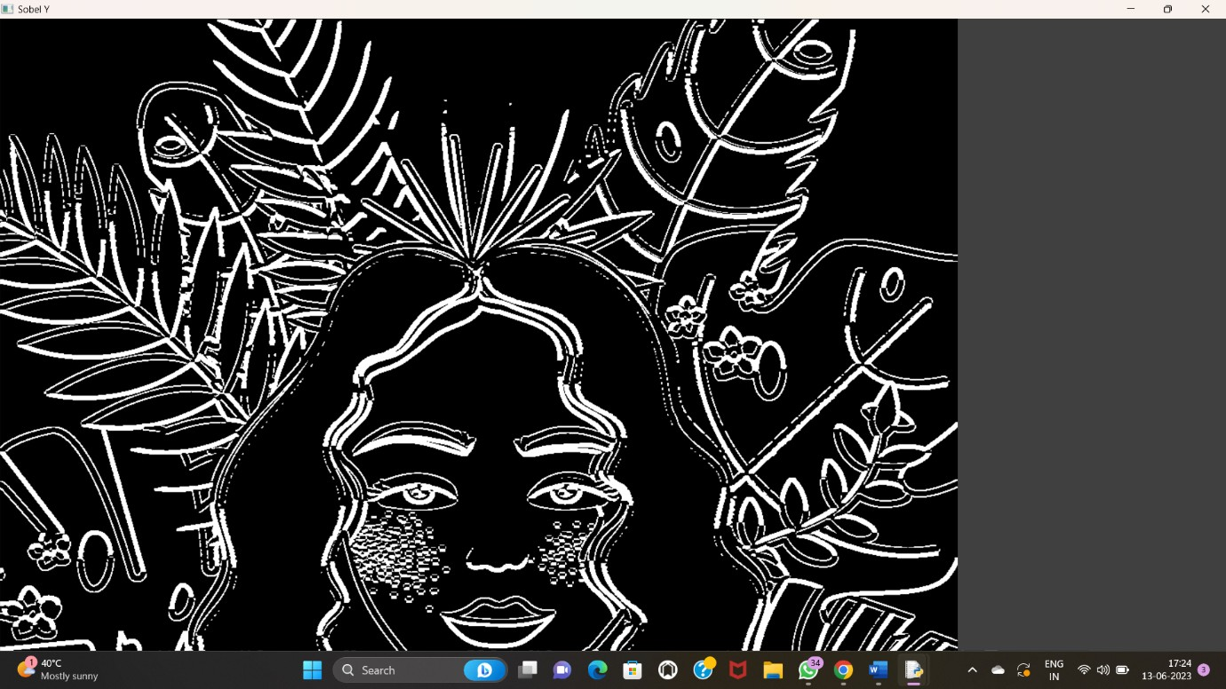cv2.waitKey(0) OUTPUT:

1. Perform Edge detection using Sobel Matrix along XY axis

PROGRAM

import cv2

img = cv2.imread("C:/Users/Welcome/OneDrive/Pictures/Saved Pictures/cat.jpeg") # Display original image

cv2.imshow('Original', img) cv2.waitKey(0)

img_gray = cv2.cvtColor(img, cv2.COLOR_BGR2GRAY) # Blur the image for better edge detection

img_blur = cv2.GaussianBlur(img_gray, (3,3), 0)

sobelxy = cv2.Sobel(src=img_blur, ddepth=cv2.CV_64F, dx=1, dy=1, ksize=5) # Combined X and Y Sobel Edge Detection

cv2.imshow('Sobel X Y using Sobel() function', sobelxy) cv2.waitKey(0)

OUTPUT:

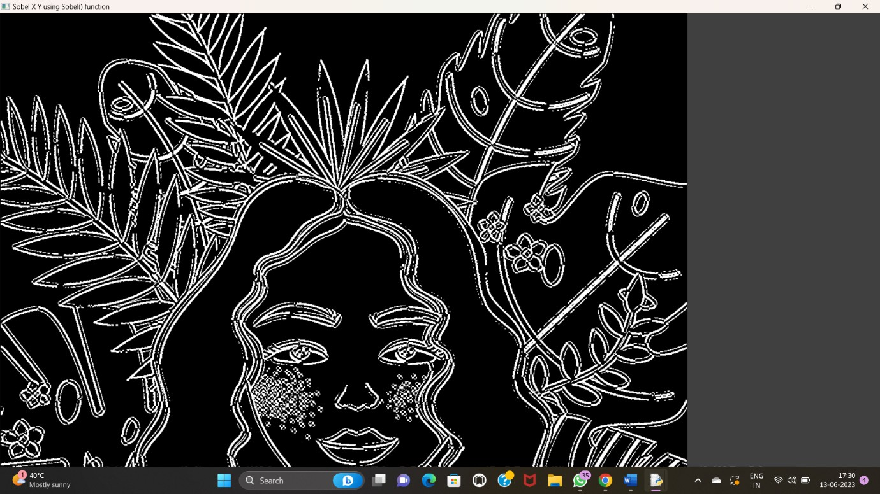

1. Perform Sharpening of Image using Laplacian mask with negative center coefficient.

PROGRAM:

import cv2

import numpy as np

img = cv2.imread("C:/Users/DIVYA/OneDrive/Pictures/ss.png") gray = cv2.cvtColor(img, cv2.COLOR_BGR2GRAY)

kernel = np.array([[0,1,0], [1,-8,1], [0,1,0]]) sharpened = cv2.filter2D(gray,-1, kernel) cv2.imshow('Original', gray) cv2.imshow('Sharpened', sharpened) cv2.waitKey(0)

cv2.destroyAllWindows()

OUTPUT:

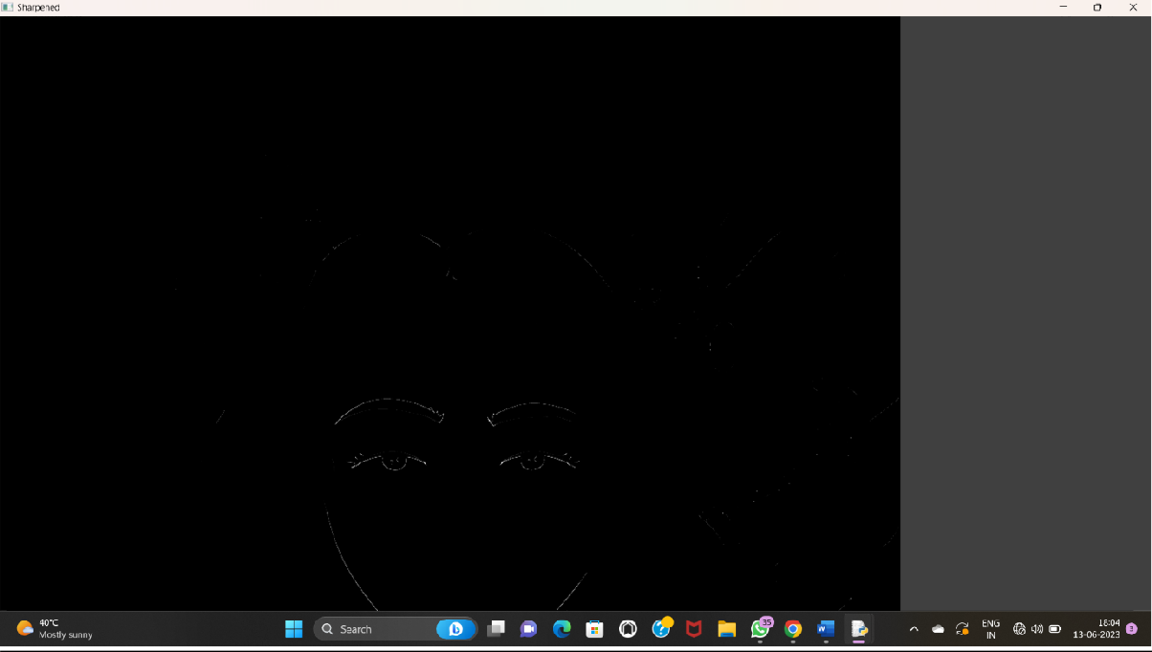

1. Perform Sharpening of Image using Laplacian mask implemented with an extension of diagonal neighbors,

PROGRAM

import cv2

import numpy as np

img = cv2.imread("C:/Users/Dama Prasoona/OneDrive/Pictures/21.png") gray = cv2.cvtColor(img, cv2.COLOR_BGR2GRAY)

kernel = np.array([[0,1,0], [1,-4,1], [0,1,0]]) sharpened = cv2.filter2D(gray,-1, kernel) cv2.imshow('Original', gray) cv2.imshow('Sharpened', sharpened) cv2.waitKey(0)

cv2.destroyAllWindows()

OUTPUT

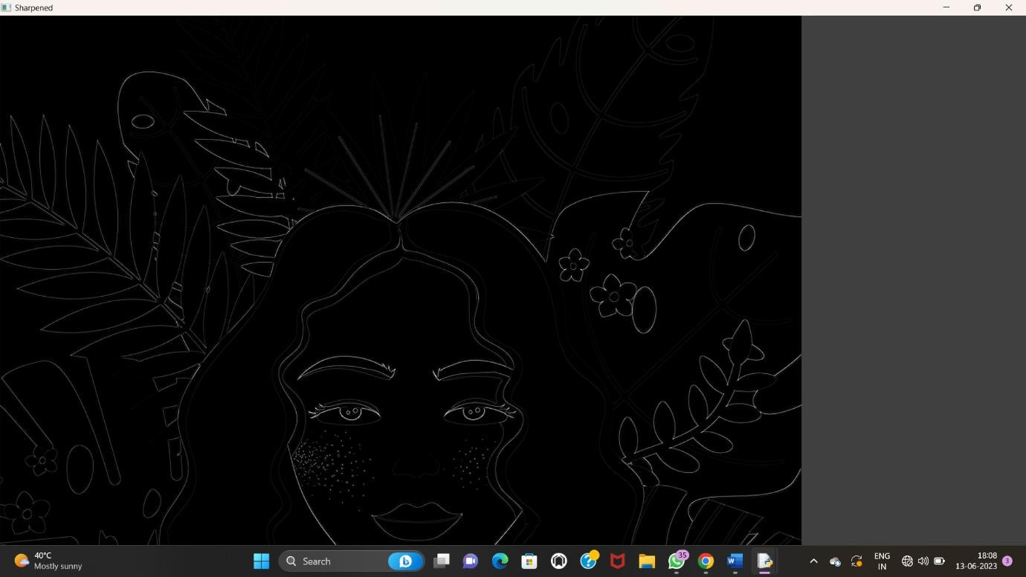

1. Perform Sharpening of Image using Laplacian mask with positive center coefficient.

PROGRAM:

import cv2

import numpy as np

img = cv2.imread("C:/Users/divya/Downloads/Girl with a Cat.png") img = cv2.resize(img,(255, 255))

gray_img = cv2.cvtColor(img, cv2.COLOR_BGR2GRAY)

# Apply the Laplacian filter with a positive center coefficient laplacian_kernel = np.array([[0,-1, 0], [-1, 5,-1], [0,-1, 0]])

sharpened_img = cv2.filter2D(gray_img,-1, laplacian_kernel)

sharpened_img = cv2.cvtColor(sharpened_img, cv2.COLOR_GRAY2BGR) cv2.imshow('Original Image', img)

cv2.imshow('Sharpened Image', sharpened_img) cv2.waitKey(0)

cv2.destroyAllWindows()

OUTPUT:

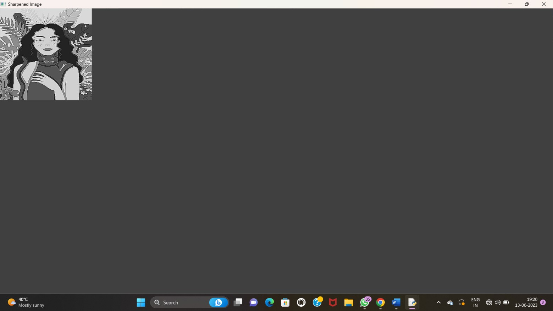

1. Perform Sharpening of Image using unsharp masking.

PROGRAM:

import cv2

import numpy as np

img = cv2.imread("C:/Users/divya/Downloads/Girl with a Cat.png") gray = cv2.cvtColor(img, cv2.COLOR_BGR2GRAY)

laplacian_kernel = np.array([[0, 1, 0],

[1,-4, 1],

[0, 1, 0]])

laplacian = cv2.filter2D(gray,-1, laplacian_kernel) sharpened = cv2.add(gray, laplacian) cv2.imshow('Original Image', gray) cv2.imshow('Sharpened Image', sharpened) cv2.waitKey(0)

cv2.destroyAllWindows()

OUTPUT:

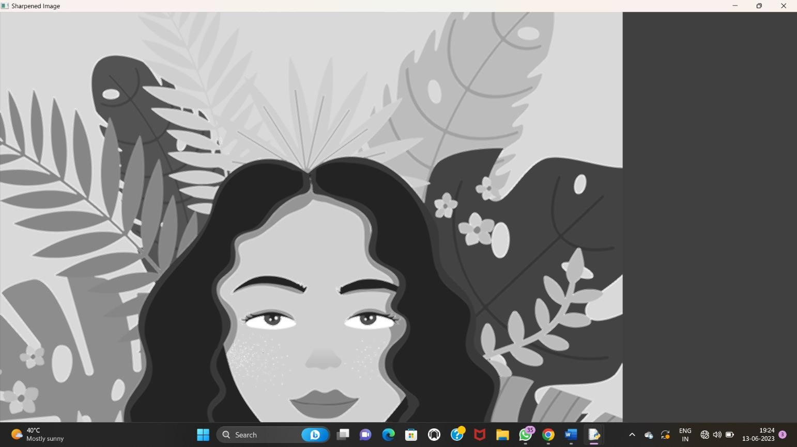

1. Perform Sharpening of Image using High-Boost Masks.

PROGRAM:

h_img, w_img, _ = resized_img.shape center_y = int(h_img/2)

center_x = int(w_img/2)

h_wm, w_wm, _ = resized_wm.shape top_y = center_y- int(h_wm/2)

left_x = center_x- int(w_wm/2) bottom_y = top_y + h_wm

right_x = left_x + w_wm

roi = resized_img[top_y:bottom_y, left_x:right_x] result = cv2.addWeighted(roi, 1, resized_wm, 0.3, 0) resized_img[top_y:bottom_y, left_x:right_x] = result

filename = "C:/Users/divya/Downloads/Girl with a Cat.png" cv2.imwrite(filename, resized_img)

cv2.imshow("Resized Input Image", resized_img) cv2.waitKey(0)

cv2.destroyAllWindows() OUTPUT:

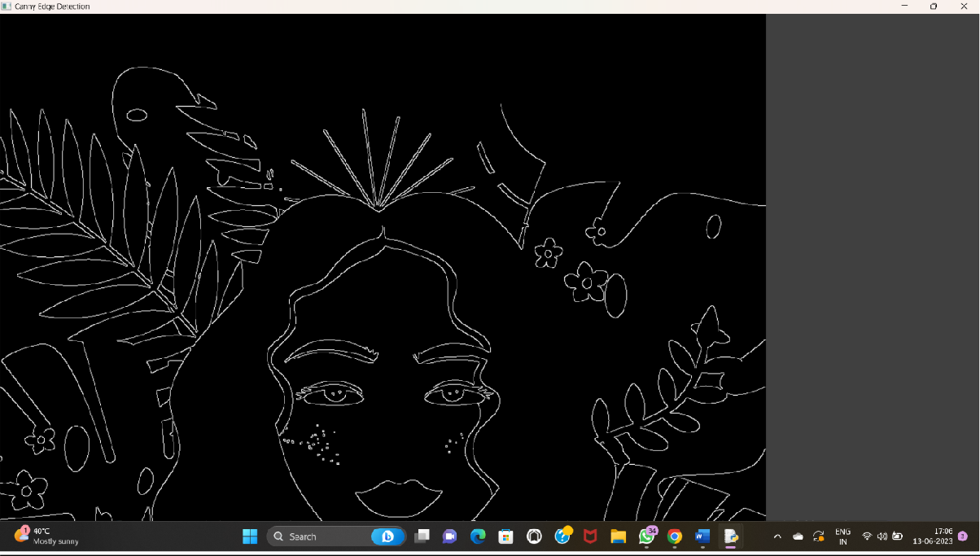

1. Perform Sharpening of Image using Gradient masking

PROGRAM:

a=imread("C:/Users/divya/Downloads/Girl with a Cat.png"); Lap=[0, 1, 0, 1,-4, 1, 0, 1, 0];

a1=conv2(a,Lap,"C:/Users/divya/Downloads/Girl with a Cat.png"); a2=uint8(a1);

imtool(abs(a-a2),[])

lap=[-1 ,-1,-1,-1, 8,-1,-1,-1 ,-1];

a3=conv2(a,lap,"C:/Users/divya/Downloads/Girl with a Cat.png"); a4=uint8(a3);

imtool(abs(a+a4),[])

OUTPUT:

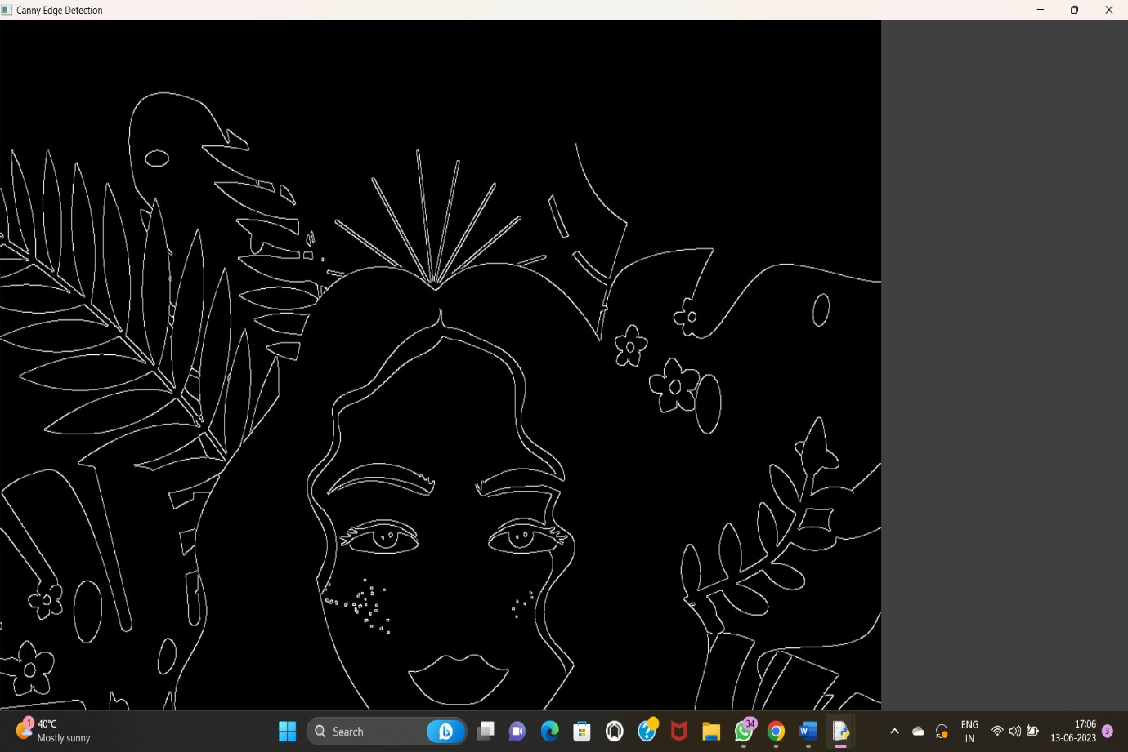

1. Insert water marking to the image using OpenCV.

PROGRAM:

import cv2

img = cv2.imread("C:/Users/divya/Downloads/Girl with a Cat.png")

wm = cv2.imread("C:/Users/divya/OneDrive/Pictures/Saved Pictures/logo.jfif") h_wm, w_wm = wm.shape[:2]

h_img, w_img = img.shape[:2] center_x = int(w_img/2) center_y = int(h_img/2)

top_y = center_y- int(h_wm/2) left_x = center_x- int(w_wm/2) bottom_y = top_y + h_wm

right_x = left_x + w_wm

\roi = img[top_y:bottom_y, left_x:right_x] result = cv2.addWeighted(roi, 1, wm, 0.3, 0)

img[top_y:bottom_y, left_x:right_x] = result cv2.imshow("Watermarked Image", img) cv2.waitKey(0)

cv2.destroyAllWindows() OUTPUT:

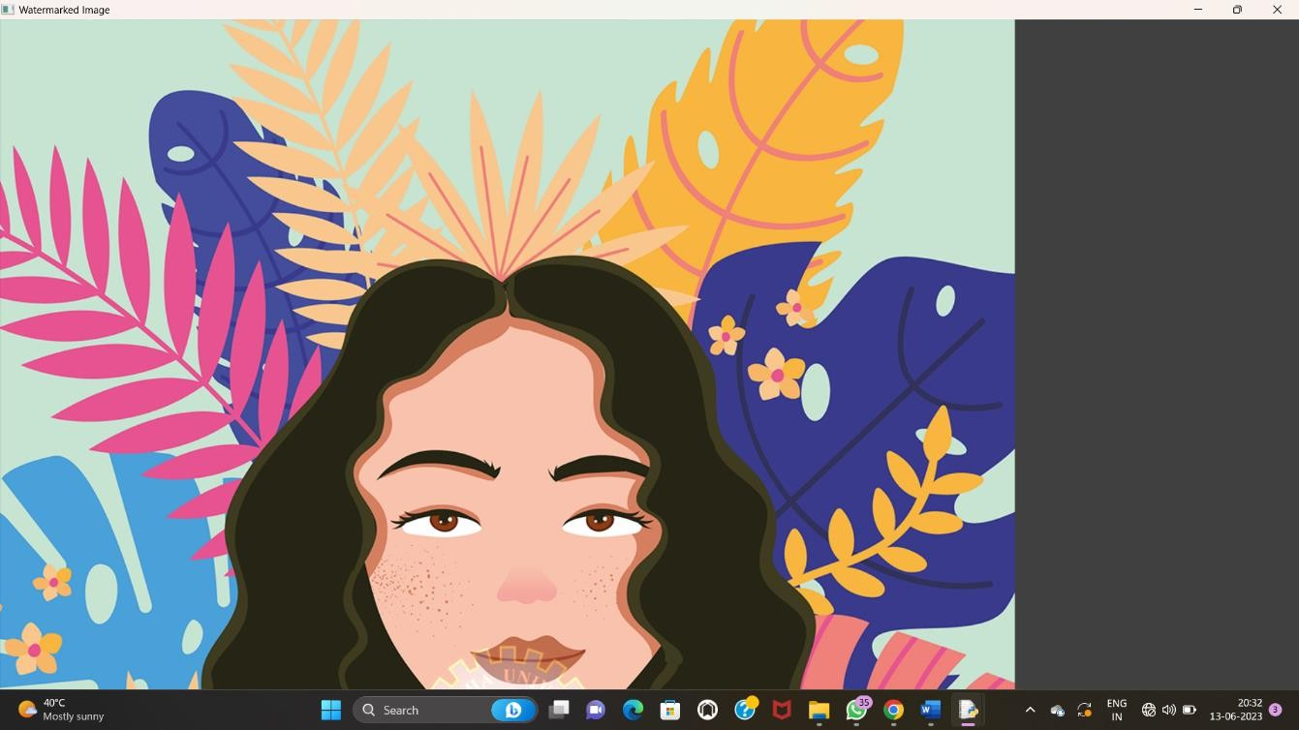

1. Do Cropping, Copying and pasting image inside another image using OpenCV

PROGRAM:

import cv2

import numpy as np

image = cv2.imread("C:/Users/divya/OneDrive/Pictures/Saved Pictures/cat.jfif") img2 = cv2.imread('C:/Users/divya/OneDrive/Pictures/Saved Pictures/logo.jfif') print(image.shape) # Print image shape

cv2.imshow("original", image) imageCopy = image.copy()

cv2.circle(imageCopy, (100, 100), 30, (255, 0, 0),-1) cv2.imshow('image', image)

cv2.imshow('image copy', imageCopy) cropped_image = image[80:280, 150:330] cv2.imshow("cropped", cropped_image)

cv2.imwrite("Cropped Image.jpg", cropped_image) dst = cv2.addWeighted(image, 0.5, img2, 0.7, 0)

img_arr = np.hstack((image, img2)) cv2.imshow('Input Images',img_arr) cv2.imshow('Blended Image',dst)

cv2.waitKey(0)

cv2.destroyAllWindows() OUTPUT:

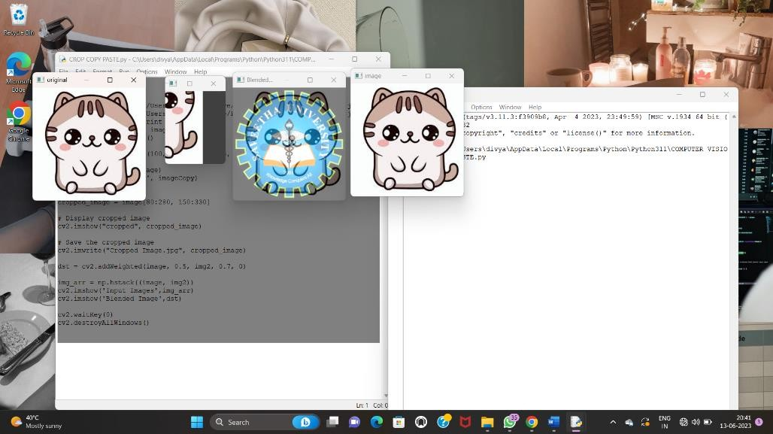

1. Find the boundary of the image using Convolution kernel for the given image

PROGRAM:

import cv2

import numpy as np

img = cv2.imread("C:/Users/divya/OneDrive/Documents/COMPUTER VISION/Girl with a Cat.png", cv2.IMREAD_GRAYSCALE)

dx = cv2.Sobel(img, cv2.CV_64F, 1, 0)

dy = cv2.Sobel(img, cv2.CV_64F, 0, 1) edges = cv2.magnitude(dx, dy)

thresh = 100

edges[edges < thresh] = 0

edges[edges >= thresh] = 255 cv2.imshow("Edges", edges) cv2.waitKey(0)

cv2.destroyAllWindows()

OUTPUT:

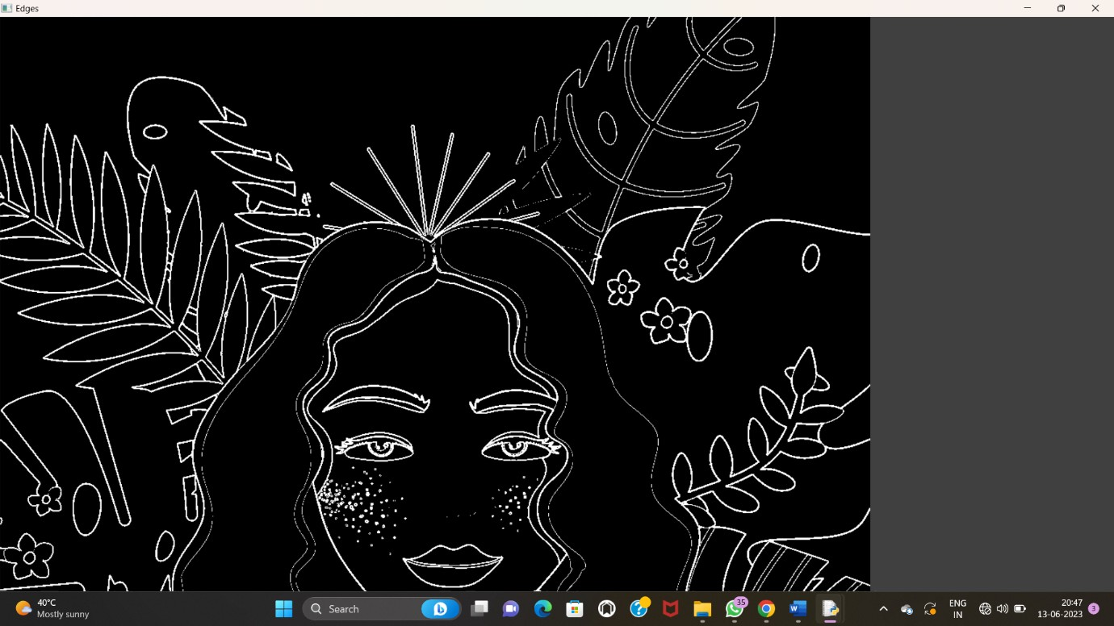

1. Morphological operations based on OpenCV using Erosion technique

PROGRAM:

import cv2

import numpy as np

img = cv2.imread("C:/Users/divya/Downloads/Girl with a Cat.png", cv2.IMREAD_GRAYSCALE) kernel = np.ones((5,5), np.uint8)

erosion = cv2.erode(img, kernel, iterations=1) cv2.imshow("Original", img)

cv2.imshow("Erosion", erosion) cv2.waitKey(0)

cv2.destroyAllWindows() OUTPUT:



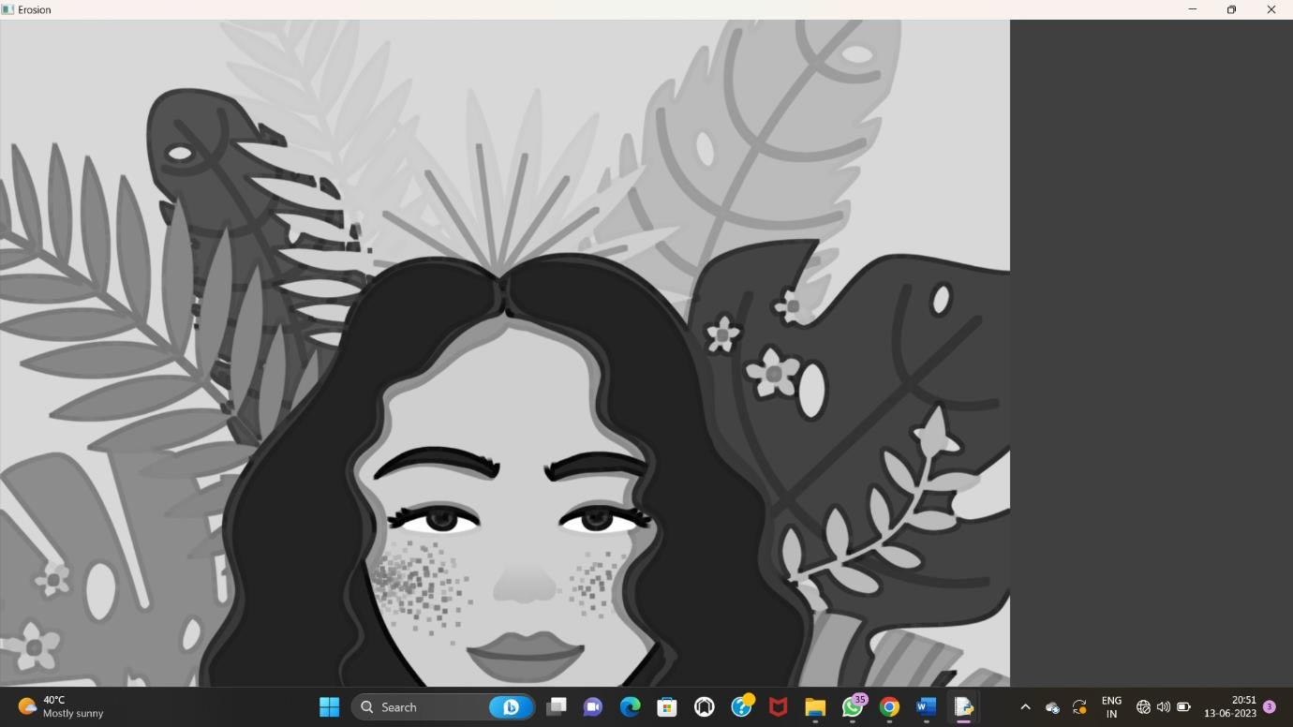

1. Morphological operations based on OpenCV using Dilation technique

PROGRAM:

import cv2

import numpy as np

img = cv2.imread("C:/Users/divya/Downloads/Girl with a Cat.png", cv2.IMREAD_GRAYSCALE) kernel = np.ones((5,5), np.uint8)

dilation = cv2.dilate(img, kernel, iterations=1) cv2.imshow("Original", img)

cv2.imshow("Dilation", dilation) cv2.waitKey(0)

cv2.destroyAllWindows()

OUTPUT:

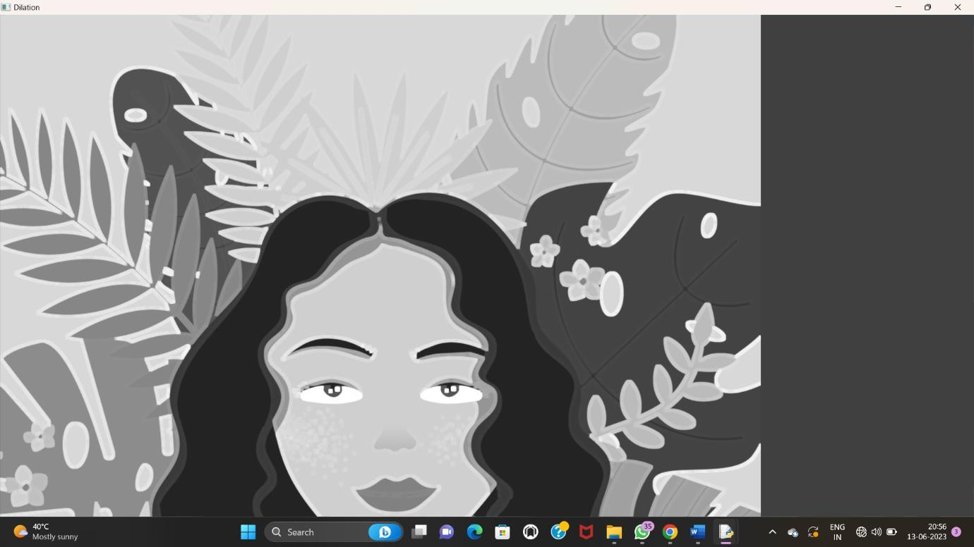

1. Morphological operations based on OpenCV using Opening technique.

PROGRAM:

import cv2

import numpy as np

img = cv2.imread("C:/Users/divya/Downloads/Girl with a Cat.png", cv2.IMREAD_GRAYSCALE) kernel = np.ones((5,5), np.uint8)

opening = cv2.morphologyEx(img, cv2.MORPH_OPEN, kernel) cv2.imshow("Original", img)

cv2.imshow("opening", opening) cv2.waitKey(0)

cv2.destroyAllWindows()

OUTPUT:



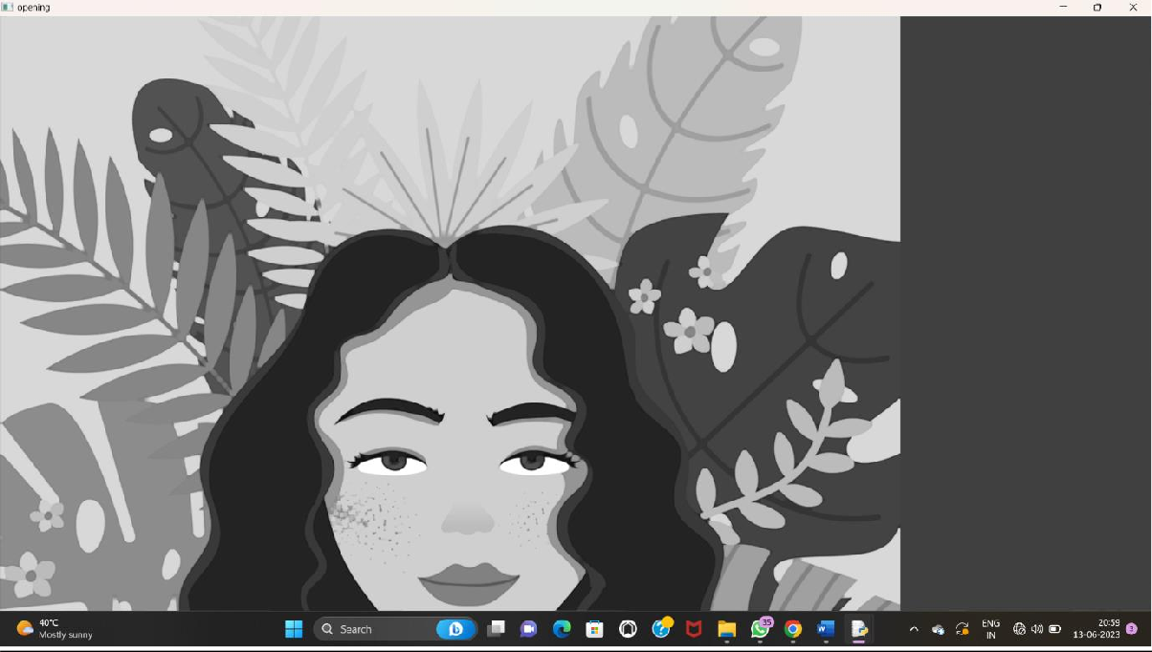

1. Morphological operations based on OpenCV using Closing technique.

PROGRAM:

import cv2

import numpy as np

img = cv2.imread("C:/Users/divya/Downloads/Girl with a Cat.png", cv2.IMREAD_GRAYSCALE) kernel = np.ones((5,5), np.uint8)

closing = cv2.morphologyEx(img, cv2.MORPH_CLOSE, kernel) cv2.imshow("Original", img)

cv2.imshow("Closing", closing) cv2.waitKey(0)

cv2.destroyAllWindows() OUTPUT:



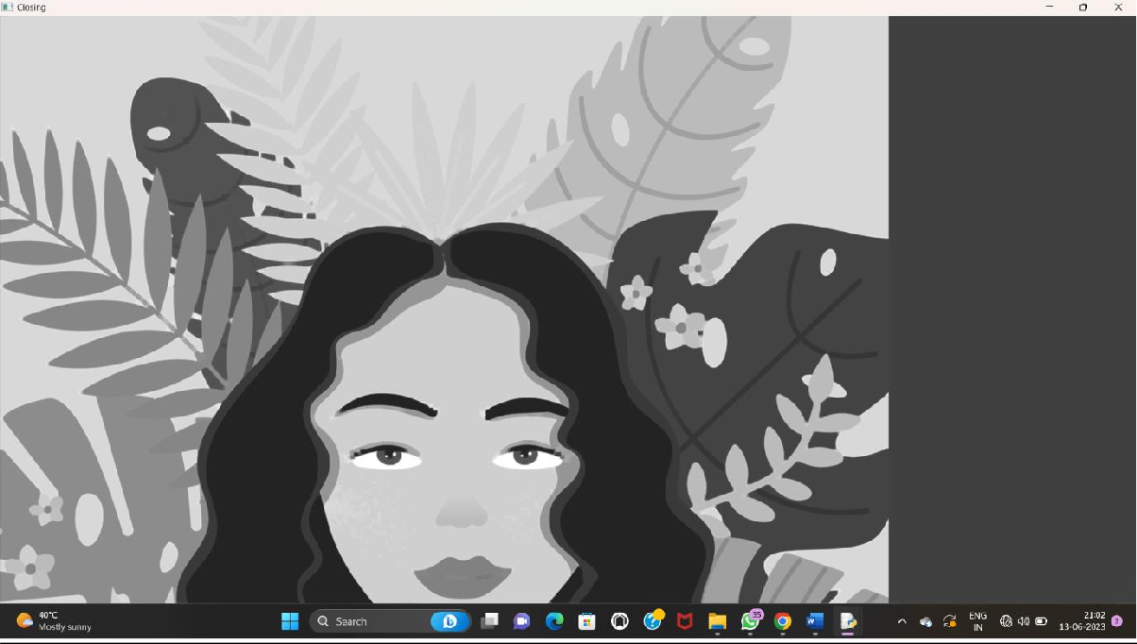

1. Morphological operations based on OpenCV using Morphological Gradient technique

PROGRAM:

import cv2

import numpy as np

img = cv2.imread("C:/Users/divya/OneDrive/Documents/COMPUTER VISION/Girl with a Cat.png", cv2.IMREAD_GRAYSCALE)

kernel = np.ones((5,5), np.uint8)

grad = cv2.morphologyEx(img, cv2.MORPH_GRADIENT, kernel) cv2.imshow("Original", img)

cv2.imshow("Gradient", grad) cv2.waitKey

OUTPUT:

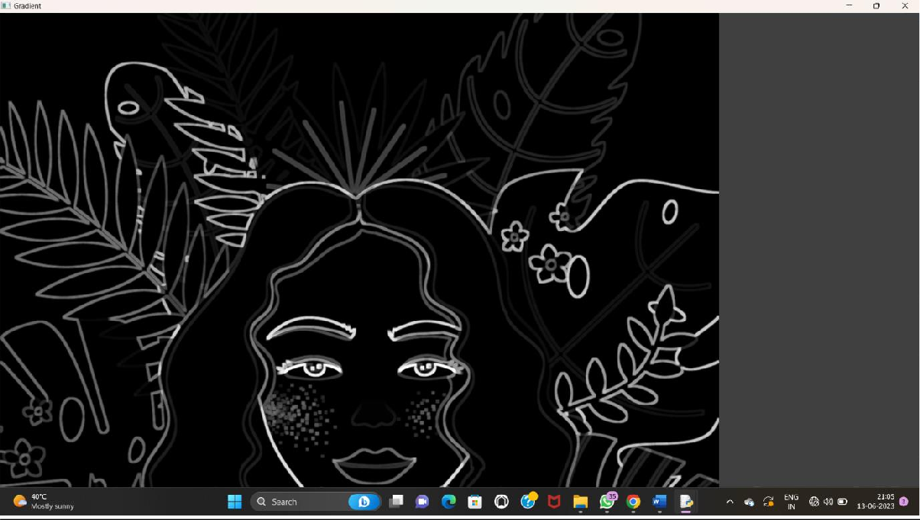

1. Morphological operations based on OpenCV using Top hat technique.

PROGRAM:

import cv2

import numpy as np

img = cv2.imread("C:/Users/koppo/Downloads/Genshin-Impact_Key-Art-EN-920x518.png", cv2.IMREAD_GRAYSCALE)

kernel = np.ones((5,5), np.uint8)

tophat = cv2.morphologyEx(img, cv2.MORPH_TOPHAT, kernel) cv2.imshow("Original", img)

cv2.imshow("Top Hat", tophat) cv2.waitKey(0)

cv2.destroyAllWindows() OUTPUT:



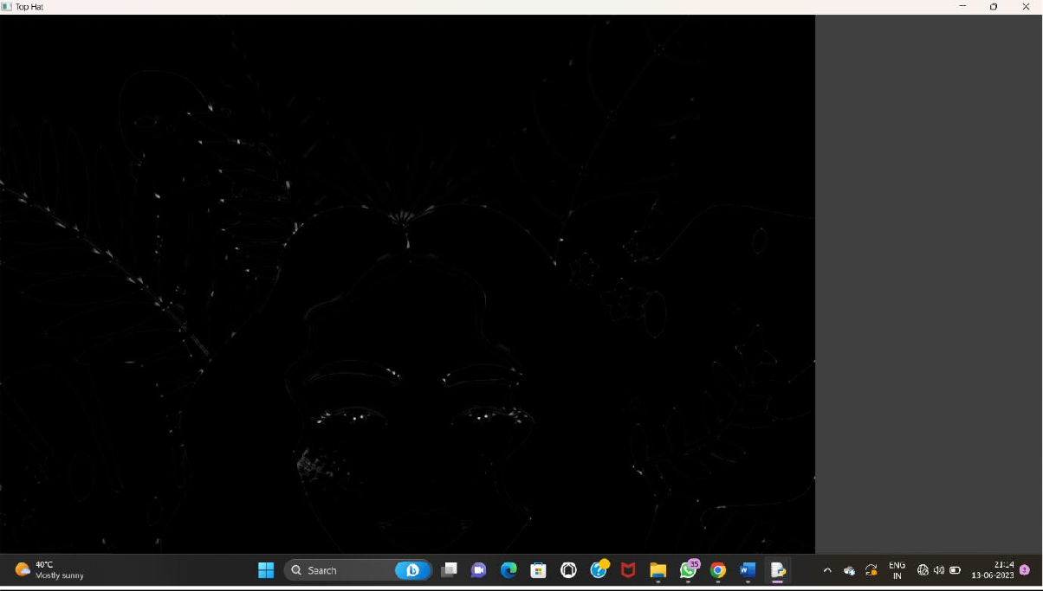

1. Morphological operations based on OpenCV using Black hat technique.

PROGRAM:

import cv2

import numpy as np

img = cv2.imread("C:/Users/divya/OneDrive/Documents/COMPUTER VISION/Girl with a Cat.png", cv2.IMREAD_GRAYSCALE)

kernel = np.ones((5,5), np.uint8)

blackhat = cv2.morphologyEx(img, cv2.MORPH_BLACKHAT, kernel) cv2.imshow("Original", img)

cv2.imshow("Black Hat", blackhat) cv2.waitKey(0)

cv2.destroyAllWindows() OUTPUT:



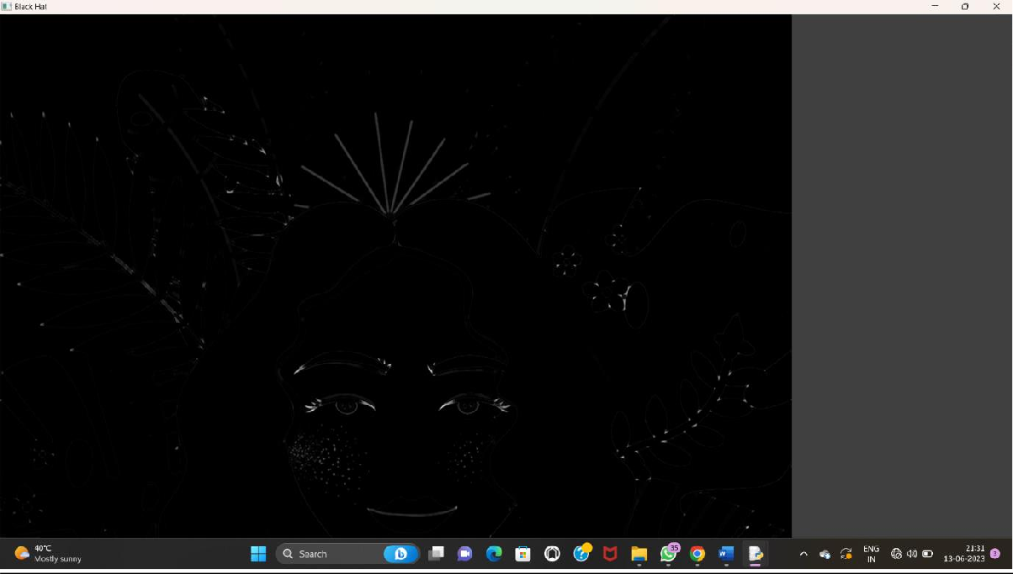

1. Recognise watch from the given image by general Object recognition using OpenCV.

PROGRAM:

import cv2

watch_cascade = cv2.CascadeClassifier("C:/Users/divya/OneDrive/Documents/COMPUTER VISION/watch-cascade.xml")

img = cv2.imread("C:/Users/divya/OneDrive/Documents/COMPUTER VISION/COMPUTER VISION/watch.jpg")

gray = cv2.cvtColor(img, cv2.COLOR_BGR2GRAY)

watches = watch_cascade.detectMultiScale(gray, scaleFactor=1.2, minNeighbors=5) for (x, y, w, h) in watches:

cv2.rectangle(img, (x, y), (x + w, y + h), (0, 255, 0), 2) cv2.imshow('Watches Detected', img)

cv2.waitKey(0)

cv2.destroyAllWindows() OUTPUT:



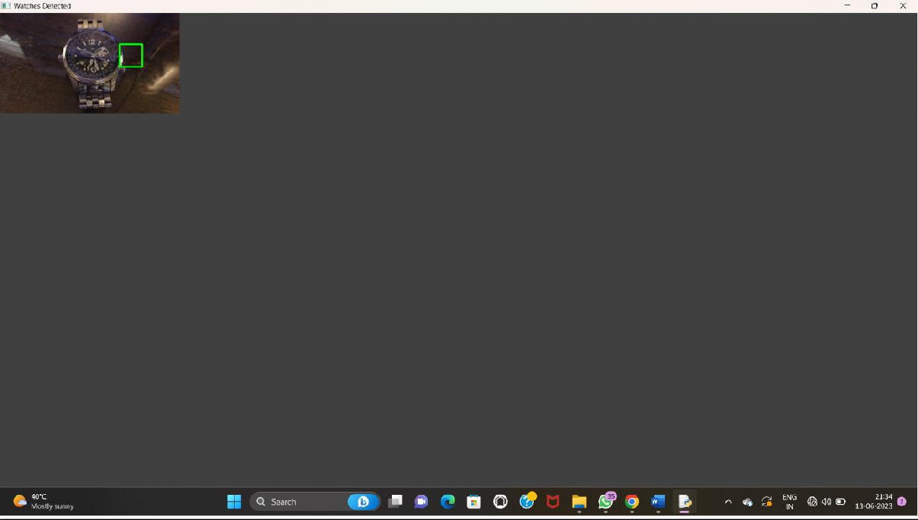

1. Using Opencv play Video in Reverse mode.

PROGRAM:

import cv2

cap = cv2.VideoCapture("C:/Users/divya/OneDrive/Documents/COMPUTER VISION/13 REASONS WHY")

total_frames = cap.get(cv2.CAP_PROP_FRAME_COUNT) current_frame = total_frames- 1

while current_frame >= 0:

cap.set(cv2.CAP_PROP_POS_FRAMES, current_frame) ret, frame = cap.read()

if not ret:

break

cv2.imshow('Video in Reverse', frame) if cv2.waitKey(25) & 0xFF == ord('q'):

break

current_frame-= 1 cap.release()

cv2.destroyAllWindows() OUTPUT:

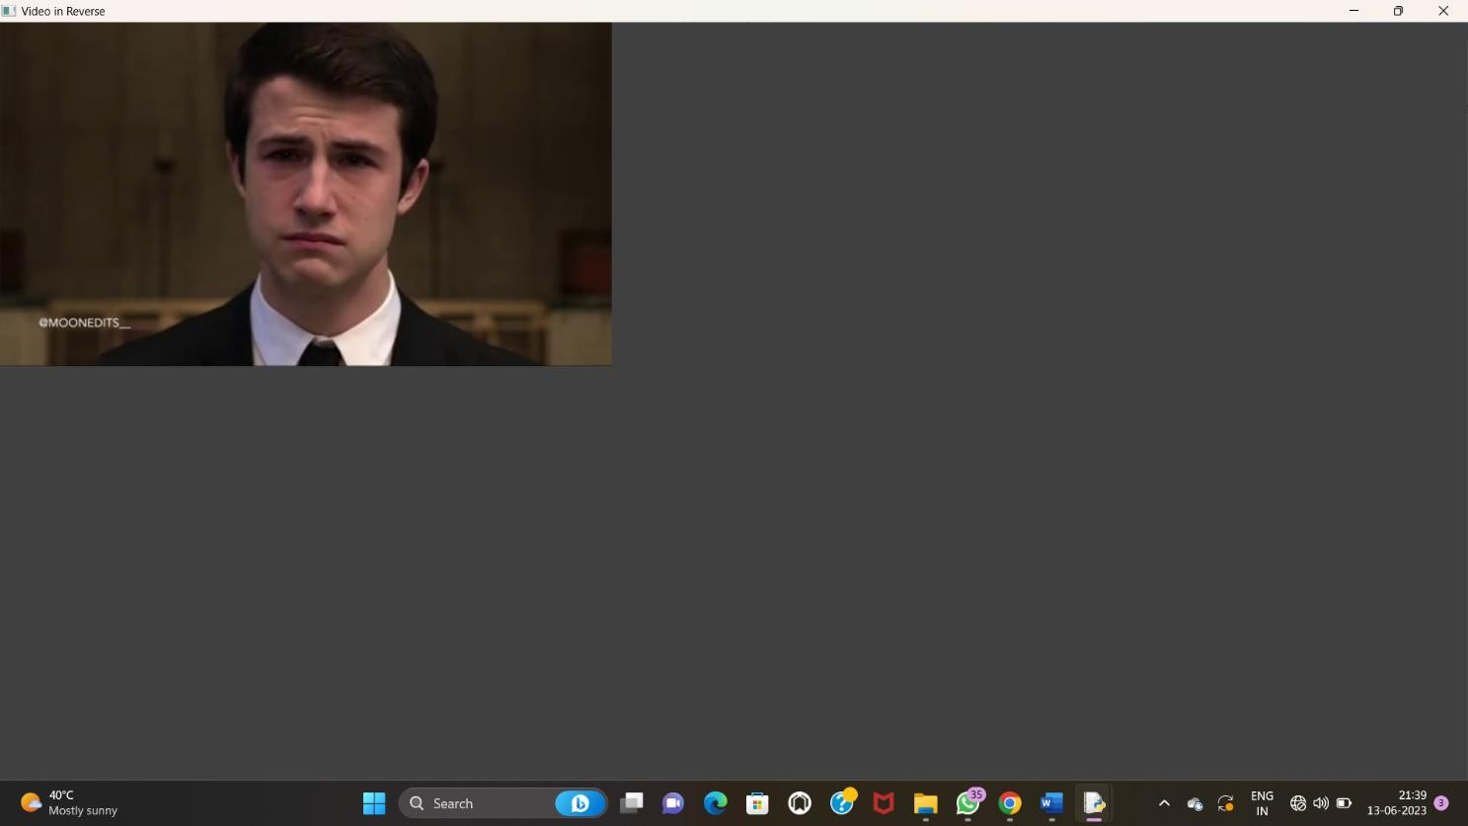

1. Face Detection using Opencv

PROGRAM:

import cv2

img = cv2.imread("C:/Users/koppo/Downloads/20101123131216-1_0.jpg") gray = cv2.cvtColor(img, cv2.COLOR_BGR2GRAY)

face_cascade =

cv2.CascadeClassifier("C:/Users/koppo/Downloads/haarcascade_frontalface_default.xml") faces = face_cascade.detectMultiScale(gray, scaleFactor=1.1, minNeighbors=5)

for (x, y, w, h) in faces:

cv2.rectangle(img, (x, y), (x + w, y + h), (0, 255, 0), 2) cv2.imshow('Faces Detected', img)

cv2.waitKey(0)

cv2.destroyAllWindows() OUTPUT:

1. Vehicle Detection in a Video frame using OpenCV PROGRAM:

import cv2

car_cascade = cv2.CascadeClassifier("C:/Users/divya/OneDrive/Documents/COMPUTER VISION/cars.xml")

cap = cv2.VideoCapture("C:/Users/divya/Downloads/car.mp4") while True:

ret, frame = cap.read()

gray = cv2.cvtColor(frame, cv2.COLOR_BGR2GRAY) cars = car_cascade.detectMultiScale(gray, 1.1, 1)

for (x,y,w,h) in cars:

cv2.rectangle(frame, (x,y), (x+w,y+h), (0,0,255), 2) cv2.imshow('frame', frame)

if cv2.waitKey(1) & 0xFF == ord('q'): break

cap.release() cv2.destroyAllWindows()

OUTPUT:

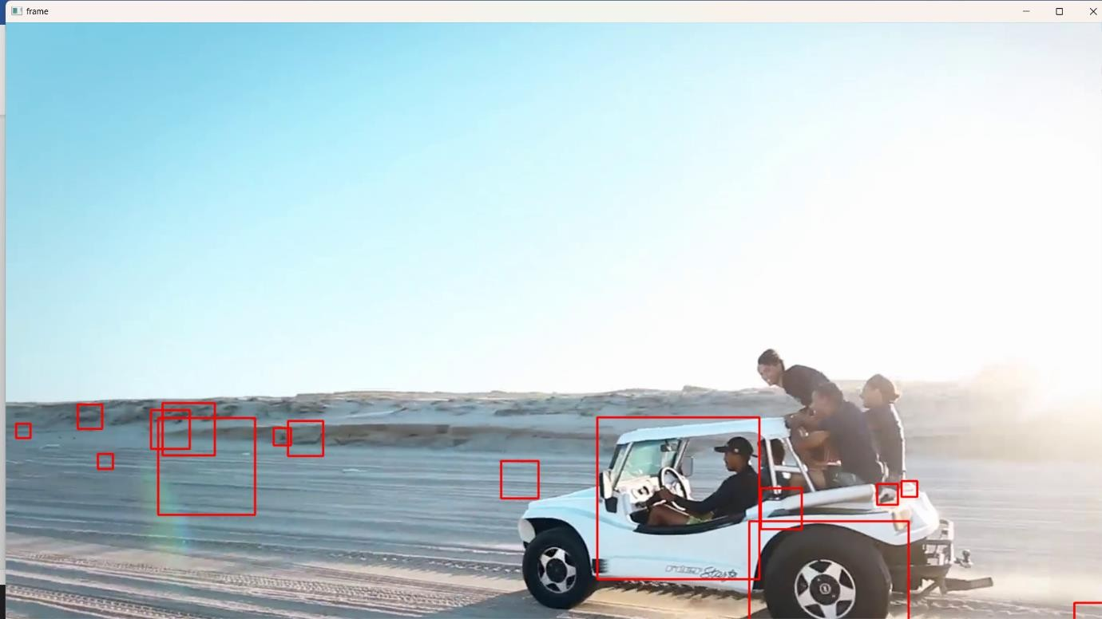

1. Draw Rectangular shape and extract objects

PROGRAM:

import cv2

img = cv2.imread("C:/Users/divya/OneDrive/Documents/COMPUTER VISION/40.jpg") x, y = 100, 100

width, height = 200, 150

roi = img[y:y+height, x:x+width] cv2.imshow('ROI', roi)

cv2.waitKey(0)

cv2.destroyAllWindows()

OUTPUT:

